STATISTICAL ANALYSIS AND PREDICTIVE MODELING USING R

Internship Project – Week 3 Deliverable


This Photo by Unknown Author is licensed under CC BY

Prepared By: Mudrika Mishra
Program: PGDM – Business Analytics
Institute: Jaipuria Institute of Management, Noida
Internship: Virtual R Data Analyst Internship
Reporting Period: Week 3 – October 2026

Executive Summary
This project focuses on applying statistical analysis and predictive modeling techniques to Reliance Industries' stock market data using R. The primary objective is to examine relationships among market variables, investigate the distribution of daily stock returns, evaluate relevant statistical assumptions, and develop a regression model for predicting daily returns.
The dataset contains 248 observations covering the period from 6 May 2025 to 5 May 2026. The analysis included correlation testing, descriptive statistical analysis, a histogram with a density curve, normality testing, and regression diagnostics. A linear regression model was developed using previous-day closing price, trading volume, and daily returns as predictors.
The dataset was divided chronologically into training and testing subsets using an 80:20 split. The model achieved a test Mean Absolute Error (MAE) of approximately 0.01307, a Root Mean Squared Error (RMSE) of approximately 0.01648, and a test R-squared of approximately 0.05164. The model performed slightly better than a baseline forecast based on the training-set mean return, although its overall predictive performance remained limited.
The diagnostic tests identified a significant departure from normality in the training residuals, while the Breusch–Pagan test did not provide significant evidence of heteroscedasticity. These findings highlight both the usefulness and limitations of statistical modeling in financial data analysis.

1. Introduction
Financial market data provides useful information for understanding price movements, trading activity, and daily return fluctuations. Statistical analysis can help identify relationships among market variables and assess whether historical information has explanatory or predictive value.
This project uses Reliance Industries stock market data to demonstrate the application of statistical techniques and predictive modeling in R. The analysis examines opening, highest, lowest, and closing prices, trading volume, and daily returns.
The project also evaluates a linear regression model using a chronological training and testing split. Rather than assuming that a model will accurately predict stock market movements, the study assesses its performance using measurable evaluation metrics and diagnostic tests.
The main objectives of this project are:
- To examine the statistical characteristics of Reliance Industries stock market data.
- To test the relationship between trading volume and closing price.
- To investigate the distribution and normality of daily stock returns.
- To develop a linear regression model using previous-day market information.
- To evaluate model performance using MAE, RMSE, and test R-squared.
- To compare the regression model with a simple baseline forecast.
- To examine model assumptions through residual analysis and the Breusch–Pagan test.
- To identify limitations and recommend improvements for future modeling.

2. Dataset Description and Selection Rationale
The dataset contains daily stock market observations for Reliance Industries from 6 May 2025 to 5 May 2026. It includes 248 observations and seven variables: DATE, OPEN, HIGH, LOW, CLOSE, VOLUME, and RETURNS.
The dataset was selected because financial market data is suitable for studying numerical relationships, return distributions, statistical assumptions, and predictive modeling. The variables allow the analysis to examine both price-related patterns and trading activity.
The dataset also provides an opportunity to evaluate the challenges of predicting financial returns, which may fluctuate substantially and may not follow a simple linear pattern.
Research focus: The project investigates whether selected historical market variables provide useful information for explaining or predicting daily returns.
dim(RIL_FINAL_xlxs)
[1] 248 7
> str(RIL_FINAL_xlxs)
tibble [248 × 7] (S3: tbl_df/tbl/data.frame)
$ DATE : POSIXct[1:248], format: "2025-05-06" "2025-05-07" "2025-05-08" ...
$ OPEN : num [1:248] 1431 1421 1404 1386 1400 ...
$ HIGH : num [1:248] 1432 1424 1421 1395 1439 ...
$ LOW : num [1:248] 1411 1403 1398 1374 1400 ...
$ CLOSE : num [1:248] 1421 1406 1407 1377 1436 ...
$ VOLUME : num [1:248] 14084117 13440169 16106175 13668904 10674081 ...
$ RETURNS: num [1:248] -0.0073 -0.0105 0.0007 -0.0212 0.0431 -0.0145 0.0061 0.0209 0.0015 -0.0107 ...
- attr(*, "na.action")= 'omit' Named int 249
..- attr(*, "names")= chr "249"
> head(RIL_FINAL_xlxs)
# A tibble: 6 × 7
DATE OPEN HIGH LOW CLOSE VOLUME RETURNS
<dttm> <dbl> <dbl> <dbl> <dbl> <dbl> <dbl>
1 2025-05-06 00:00:00 1431 1432 1411. 1421. 14084117 -0.0073
2 2025-05-07 00:00:00 1421. 1424. 1403. 1406 13440169 -0.0105
3 2025-05-08 00:00:00 1404. 1421. 1398 1407 16106175 0.0007
4 2025-05-09 00:00:00 1386. 1395. 1374. 1377. 13668904 -0.0212
5 2025-05-12 00:00:00 1400 1439 1400 1436. 10674081 0.0431
6 2025-05-13 00:00:00 1434. 1448. 1412. 1416. 11407896 -0.0145
> summary(RIL_FINAL_xlxs)
DATE OPEN HIGH LOW CLOSE
Min. :2025-05-06 00:00:00 Min. :1295 Min. :1308 Min. :1290 Min. :1305
1st Qu.:2025-07-30 18:00:00 1st Qu.:1387 1st Qu.:1401 1st Qu.:1377 1st Qu.:1389
Median :2025-10-30 12:00:00 Median :1424 Median :1434 Median :1410 Median :1423
Mean :2025-10-31 06:40:38 Mean :1438 Mean :1450 Mean :1426 Mean :1437
3rd Qu.:2026-01-30 12:00:00 3rd Qu.:1485 3rd Qu.:1495 3rd Qu.:1474 3rd Qu.:1484
Max. :2026-05-05 00:00:00 Max. :1593 Max. :1612 Max. :1578 Max. :1592
VOLUME RETURNS
Min. : 2066169 Min. :-0.0460000
1st Qu.: 8119787 1st Qu.:-0.0077000
Median :10819218 Median : 0.0002000
Mean :12552205 Mean : 0.0001742
3rd Qu.:14813751 3rd Qu.: 0.0070000
Max. :41027699 Max. : 0.0431000

>

Figure 1. Dataset structure and descriptive summary in R.

3. Correlation Analysis and Hypothesis
A Pearson correlation test was conducted to examine the linear relationship between trading volume and closing price.
The hypotheses were defined as follows:
Null Hypothesis (H₀): There is no linear correlation between trading volume and closing price in the population.
Alternative Hypothesis (H₁): There is a non-zero linear correlation between trading volume and closing price in the population.
The significance level was set at 0.05. The Pearson correlation coefficient and its p-value were used to assess the strength, direction, and statistical significance of the relationship.
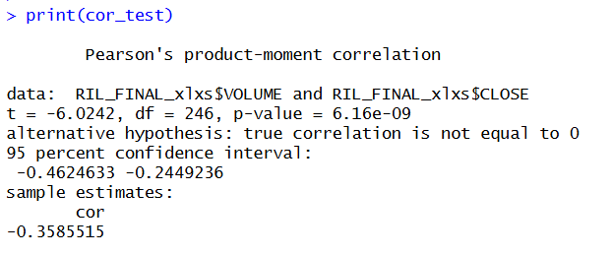
Figure 2. Pearson correlation test between trading volume and closing price.
What does this result mean in simple terms?
The correlation coefficient between trading volume and closing price was approximately -0.3586. This indicates a moderate negative linear relationship in the analyzed dataset. The p-value was approximately 6.16 × 10⁻⁹, which is considerably below the significance level of 0.05.
In practical terms, observations with higher trading volumes tended to be associated with lower closing prices in this sample. However, this does not mean that every increase in trading volume was followed by a decrease in price. Other market factors may also influence stock prices, and correlation alone cannot establish a cause-and-effect relationship.

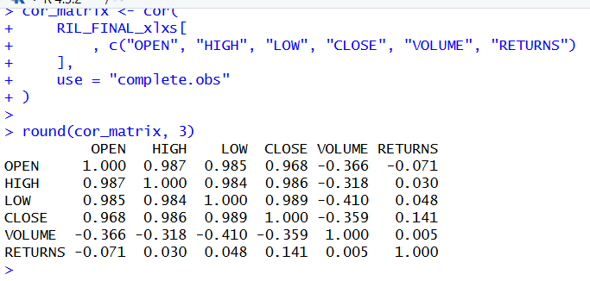
Figure 3. Correlation matrix of numerical stock market variables.
The correlation matrix showed strong positive correlations among opening, high, low, and closing prices. For example, the correlation between LOW and CLOSE was approximately 0.989. Such strong relationships indicate that including several price variables together in a regression model could create multicollinearity concerns.
Trading volume and daily returns had an almost zero linear correlation of approximately 0.0052. This suggests that trading volume alone had little linear association with daily returns in the analyzed sample. However, a near-zero correlation does not rule out nonlinear relationships or other forms of dependence.

4. Distribution Analysis and Normality Testing

4.1 Histogram of Daily Returns

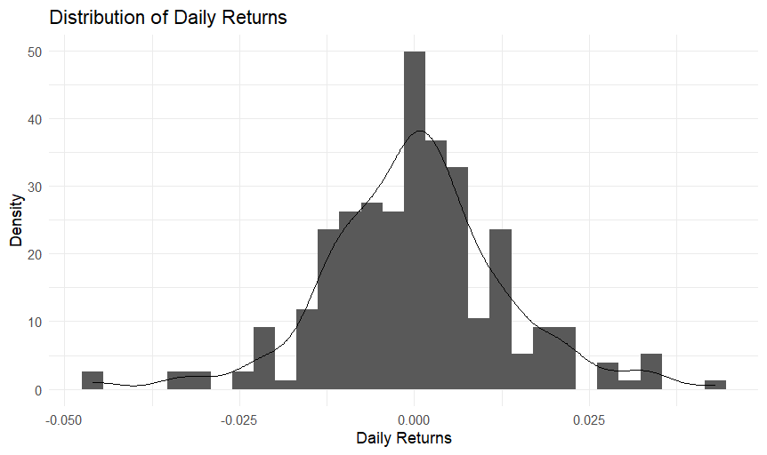

Figure 4. Distribution of daily stock returns with density curve.
The histogram and density curve were used to examine the distribution of daily stock returns. The visualization provides an overview of the concentration and spread of returns and helps identify possible departures from a symmetric distribution.
Visual inspection alone cannot determine whether the returns follow a normal distribution. Therefore, a Shapiro–Wilk test was also conducted to assess normality statistically.

4.2 Shapiro–Wilk Test for Daily Returns

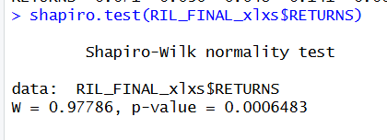
The Shapiro–Wilk test produced a W statistic of 0.97786 and a p-value of 0.0006483. Since the p-value was below 0.05, the null hypothesis of normality was rejected. This indicates that the distribution of daily returns significantly deviated from normality according to this test.
This finding is relevant because financial return data may exhibit characteristics that are not fully captured by a normal distribution. The result applies to the observed daily returns and does not, by itself, establish whether the regression model's residuals satisfy the normality assumption.

5. Predictive Modeling Methodology

5.1 Feature Engineering
To develop a predictive model, lagged variables were created so that each observation used information from the previous trading day. The predictors were the previous day's closing price, trading volume, and daily return.
The lagged variables were created after arranging the dataset in chronological order. The first observation was removed because it did not have previous-day values for all lagged predictors. The resulting modeling dataset contained 247 observations and 10 columns.
Using lagged predictors supports a more realistic time-series modeling approach because predictions are based on historical information rather than future observations.

dim(RIL_model_data)
[1] 247 10
> head(RIL_model_data)
# A tibble: 6 × 10
DATE OPEN HIGH LOW CLOSE VOLUME RETURNS PREV_CLOSE PREV_VOLUME
<dttm> <dbl> <dbl> <dbl> <dbl> <dbl> <dbl> <dbl> <dbl>
1 2025-05-07 00:00:00 1421. 1424. 1403. 1406 13440169 -0.0105 1421. 14084117
2 2025-05-08 00:00:00 1404. 1421. 1398 1407 16106175 0.0007 1406 13440169
3 2025-05-09 00:00:00 1386. 1395. 1374. 1377. 13668904 -0.0212 1407 16106175
4 2025-05-12 00:00:00 1400 1439 1400 1436. 10674081 0.0431 1377. 13668904
5 2025-05-13 00:00:00 1434. 1448. 1412. 1416. 11407896 -0.0145 1436. 10674081
6 2025-05-14 00:00:00 1420 1430. 1416. 1424. 5570160 0.0061 1416. 11407896
# ℹ 1 more variable: PREV_RETURNS <dbl>

5.3 Training and Testing Data
The modeling dataset was divided chronologically into training and testing subsets. Approximately 80% of the observations were assigned to the training set and the remaining 20% to the testing set.
The training data were used to estimate the regression coefficients, while the testing data were used to evaluate predictions on later observations. A chronological split was selected instead of random splitting because the observations represent a time series and preserving temporal order reduces the risk of using future observations to predict the past.
This procedure represents a holdout evaluation. It is not equivalent to k-fold or rolling time-series cross-validation, which could be explored in future work.
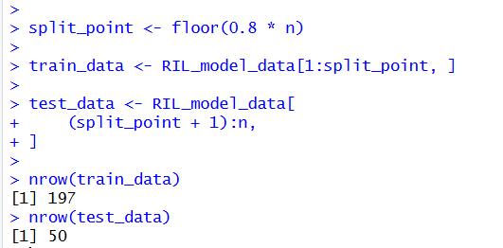
Figure 6. Chronological division of the modeling dataset.

6. Model Development
A multiple linear regression model was developed to predict the current day's return using the previous day's closing price, trading volume, and daily return.
The model can be represented as:
RETURNS = β₀ + β₁(PREV_CLOSE) + β₂(PREV_VOLUME) + β₃(PREV_RETURNS) + ε
Here, β₀ represents the intercept, β₁, β₂, and β₃ are regression coefficients, and ε represents the error term.
The model was fitted using the training dataset, and its estimated coefficients, statistical significance, and explanatory performance were examined.
Call:
lm(formula = RETURNS ~ PREV_CLOSE + PREV_VOLUME + PREV_RETURNS,
data = train_data)

Residuals:
Min 1Q Median 3Q Max
-0.041692 -0.006275 0.000316 0.006024 0.040493

Coefficients:
Estimate Std. Error t value Pr(>|t|)
(Intercept) 3.367e-02 2.016e-02 1.670 0.0965 .
PREV_CLOSE -2.399e-05 1.360e-05 -1.764 0.0794 .
PREV_VOLUME 1.181e-10 1.898e-10 0.622 0.5345
PREV_RETURNS -1.701e-02 7.201e-02 -0.236 0.8135
---
Signif. codes: 0 ‘***’ 0.001 ‘**’ 0.01 ‘*’ 0.05 ‘.’ 0.1 ‘ ’ 1

Residual standard error: 0.01184 on 193 degrees of freedom
Multiple R-squared: 0.02111, Adjusted R-squared: 0.005898
F-statistic: 1.388 on 3 and 193 DF, p-value: 0.2478

Figure 7. Linear regression model summary.
What do the regression results tell us?
The regression model achieved a training R-squared of approximately 0.0211, meaning that the selected predictors explained about 2.1% of the variation in returns within the training data. The adjusted R-squared was approximately 0.0059. The overall model had a p-value of 0.2478, which was above the 0.05 significance level.
None of the three predictors—previous-day closing price, previous-day trading volume, and previous-day returns—was individually statistically significant at the 5% level.
These findings suggest that the selected variables provided limited explanatory information about daily stock returns in this dataset. The results do not establish that historical information is entirely useless; rather, this particular linear model and predictor set did not capture much of the variation in returns.

Model Evaluation

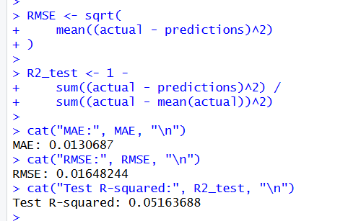
Figure 8. Evaluation metrics for the test dataset
Actual results:
- MAE = 0.0130687
- RMSE = 0.01648244
- Test R² = 0.051636.
The model achieved a test MAE of approximately 0.01307 and an RMSE of approximately 0.01648. The test R-squared was approximately 0.0516, indicating limited explanatory performance on the held-out observations.
The MAE represents the average absolute difference between actual and predicted returns. The RMSE places greater weight on larger prediction errors. Although these metrics quantify the model's performance, they do not indicate that the model is sufficiently accurate for investment decisions.

Baseline Comparison

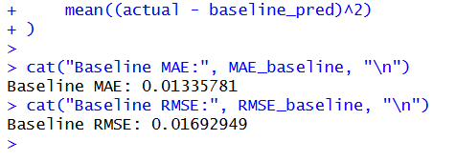
Baseline code aur output.
Metric | Linear Regression | Baseline
MAE | 0.01306870 | 0.01335781
RMSE | 0.01648244 | 0.01692949
Interpretation of Prediction Errors
The test MAE was approximately 0.01307, while the test RMSE was approximately 0.01648. Since returns are expressed in decimal form, the MAE corresponds to an average absolute prediction error of approximately 1.31 percentage points when expressed on a percentage scale. The RMSE corresponds to approximately 1.65 percentage points.
The baseline produced a higher MAE of approximately 0.01336 and a higher RMSE of approximately 0.01693. Thus, the regression model reduced both error measures slightly. However, the improvement was modest, and the test R-squared of approximately 0.0516 indicates limited explanatory performance on the test observations.
These results should not be interpreted as evidence that the model is suitable for investment decisions. Further validation and testing would be required before drawing practical forecasting conclusions.

Rolling Time-Series Cross-Validation
To evaluate the consistency of the linear regression model over different time periods, rolling time-series cross-validation was performed. Unlike random cross-validation, this approach preserves the chronological order of observations, making it more appropriate for financial time-series data.
The validation procedure used an initial training window of 120 observations, followed by a validation window of 20 observations. The training window was progressively expanded by 20 observations for each subsequent fold. A total of six validation folds were evaluated using Mean Absolute Error (MAE) and Root Mean Squared Error (RMSE).
The average MAE across the six folds was 0.01053, while the average RMSE was 0.01371. Fold-level results showed variation in predictive performance. Fold 2 recorded the lowest MAE (0.00591) and RMSE (0.00779), whereas Fold 6 recorded the highest MAE (0.01405) and RMSE (0.01877). This indicates that prediction errors differed across validation periods.
The variation in error values suggests that the model's predictive performance was not completely consistent over time. The results also highlight the difficulty of predicting daily stock returns using a limited set of lagged variables. Although the model demonstrated some predictive ability, these findings should not be interpreted as evidence of consistently accurate forecasts.
Overall, rolling time-series cross-validation provided a more robust assessment of model performance across different historical periods. Further improvements could include testing additional lagged features, comparing alternative forecasting models, and evaluating performance on additional unseen data.
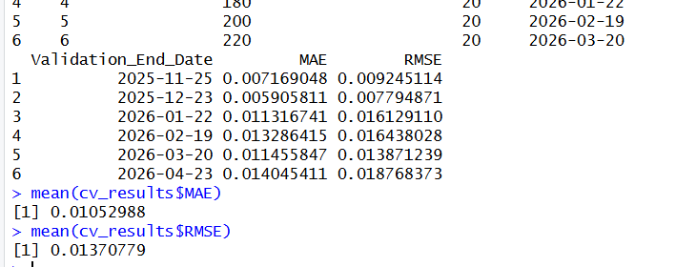
Figure: Rolling Time-Series Cross-Validation Results.
- Model Diagnostics
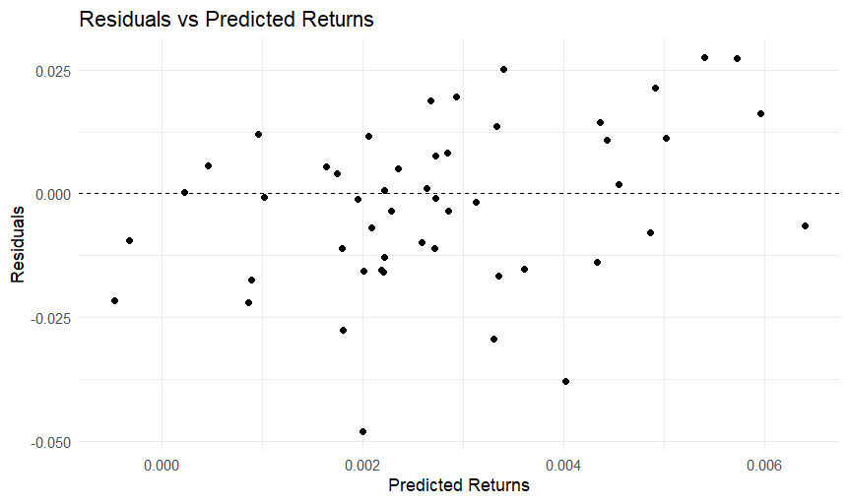
Figure 9. Residuals versus predicted returns for the test dataset.
The residuals-versus-predicted plot was examined to identify visible patterns in the prediction errors. The residuals were distributed around the zero-reference line, although the plot should be inspected for systematic patterns, changing spread, or influential observations.
A residual plot provides a visual diagnostic rather than a definitive statistical test. Since the model's predictive performance was limited, additional predictors and alternative time-series methods may be worth investigating.

10.1 Shapiro-Wilk Test on Training Residuals

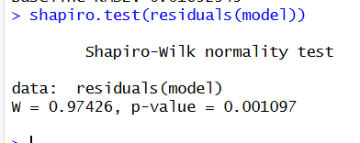
The Shapiro-Wilk test on the training model residuals returned a W statistic of 0.97426 and a p-value of 0.001097. Since the p-value was below 0.05, the null hypothesis of normally distributed residuals was rejected. This indicates a statistically significant departure from normality.
The result should be considered when interpreting regression inference. It does not automatically invalidate the fitted model, but it highlights a limitation of the model assumptions and supports further diagnostic analysis.

10.2 Breusch–Pagan Test
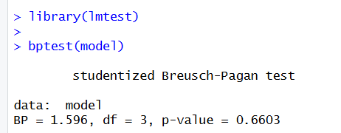
The Breusch–Pagan test returned a statistic of 1.596 with 3 degrees of freedom and a p-value of 0.6603. Since the p-value exceeded the 0.05 significance level, the null hypothesis of constant error variance was not rejected. Therefore, the test did not provide sufficient evidence of heteroscedasticity in the fitted model.
This result is consistent with the constant variance assumption, although it does not prove that the variance is perfectly constant.

Strengths, Limitations, and Potential Improvements
Strengths
The project demonstrates the application of statistical analysis, hypothesis testing, feature engineering, linear regression, and model evaluation in R. A chronological train-test split was used to preserve the time order of the stock market observations. The model was also compared with a simple baseline, providing a more informative evaluation than reporting regression metrics alone.
Limitations
The regression model had limited explanatory power, with a test R-squared of approximately 0.0516. Its performance improvement over the baseline was small. The Shapiro-Wilk test also indicated that the training residuals deviated significantly from normality. Furthermore, the evaluation used a single chronological holdout split rather than rolling time-series cross-validation. The analysis covered only one year of observations and used a limited set of predictors.
Potential Improvements
Future work could include additional historical observations, market indices, sector-level indicators, and other relevant financial variables. Alternative approaches, such as autoregressive models or other time-series forecasting methods, could be compared against the baseline. Rolling-origin evaluation could provide a more robust assessment of forecasting performance. Feature selection and careful diagnostic analysis may also help determine whether a more complex model offers meaningful improvement.

Conclusion
This project applied statistical analysis and predictive modeling techniques to Reliance Industries stock market data using R. Correlation analysis identified a statistically significant negative association between trading volume and closing price (r = -0.359, p < 0.001) in the analyzed sample. The Shapiro–Wilk test indicated that daily returns and training model residuals deviated significantly from normality, while the Breusch–Pagan test found no statistically significant evidence of heteroscedasticity (p = 0.6603).
A linear regression model was developed using previous-day closing price, trading volume, and returns as predictors. On the chronological test set, the model achieved an MAE of 0.01307, an RMSE of 0.01648, and an R-squared of 0.05164. It performed slightly better than the baseline mean forecast, but the improvement was modest.
Rolling time-series cross-validation across six validation folds produced an average MAE of 0.01053 and an average RMSE of 0.01371. However, the variation in errors across folds indicated that predictive performance was not consistent across all validation periods. The final test-set errors were higher than the cross-validation averages, suggesting that forecasting was more challenging during the final test period.
Overall, the project demonstrated the importance of combining statistical testing, visualization, chronological model evaluation, cross-validation, and diagnostic analysis. The findings also highlighted the limitations of predicting daily stock returns using a small set of lagged variables. Future work could explore additional financial indicators, alternative time-series models, and longer historical datasets to investigate whether predictive performance can be improved.

References
- R Core Team. R: A Language and Environment for Statistical Computing. R Foundation for Statistical Computing, Vienna, Austria.
- Wickham, H. ggplot2: Elegant Graphics for Data Analysis. Springer.
- Breusch, T. S., and Pagan, A. R. (1979). A Simple Test for Heteroscedasticity and Random Coefficient Variation.
- Shapiro, S. S., and Wilk, M. B. (1965). An Analysis of Variance Test for Normality (Complete Samples).
- Reliance Industries stock market dataset used for this internship project.
- https://github.com/Mudrikamishra05/Virtual-R-Data-Analyst-Internship

